Technology Leadership Forum
Tuesday May 7th 1:00pm to 5:00pm, Sutton Place Hotel, Edmonton, AB
Co-Chairs
Kexing Liu (QGenX Systems), IEEE Canada OS Committee Chair
Connie Parenteau (Telus), Member of Board of Directors at Engineers Canada

Technologies have become pervasive and fundamental to humanity. They are at the core of today’s knowledge-based economy, fueling the development of innovative products, business processes and government services. They continue to redefine business and geographic regions; form borderless environments; create new challenges and opportunities for governments. The Canada Technology Leadership Forum brings together leaders from different science and engineering associations and policy analysts to discuss technology and innovation strategies necessary to succeed in the 21st century.
1:00pm – 1:30pm
Welcome and Opening Remarks
Prof. Witold Kinsner, Past-president, IEEE Canada
Prof. David Lynch, President-elect, Engineers Canada

1:30pm – 3:00pm Panel 1 - Technology Leaders
Moderator Kexing Liu (IEEE Canada)
Panelists to participate in discussions on
- Future technologies that are essential to Canada
- The ever changing role of post-secondary education in training the future technology leaders
Panel list
- Prof. Robert Fedosejevs, Senior past president, CAP (Canadian Association of Physicists)
- Prof. Witold Kinsner, Past president, IEEE Canada
- Prof. David Lynch, President-elect, Engineers Canada

3:00pm – 3:30pm Coffee Break

3:30pm – 5:00pm Panel 2 – Technology Commercialization
Moderator Connie Parenteau (APEGA),
Panelists will
- Explore how to leverage technology changes to improve competitiveness of Canada
- Identify gaps between innovation and technology commercialization in Canada
Panelist:
- Rosalie Wyonch, Senior policy analyst, C.D. Howe Institute
- Ravinder Shergill, Principal Technology Architect, Telus
- Carla Otto, Director Regional Innovation, Alberta Innovates

5:00pm Adjourn

The forum is free for general public. Attendees must register by following the link below:
https://ieeecanada-technologyforum.eventbrite.ca
For more information please contact kexing.liu@ieee.org
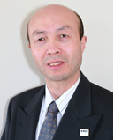
Kexing Liu received his B.Sc. degree from Beijing Polytechnic University, China on manufacturing automation; and the Ph.D. degree from the University of Manchester (UMIST), UK on fiber optics and analytical instrumentation. Dr Liu started his career in scientific research and then moved to development of technology based products.

He was a visiting scientist with the Technical University of Hamburg-Harburg, Germany working on measurement of integrated optics. In 1988 He joint University of Toronto Institute for Aerospace Studies as a research associate where he investigated fiber optics for various aerospace applications. Dr Liu has published more than 30 scientific papers on fiber optics and photonics. He is inventor/co-inventor for 17 granted patents ranging from photonics, optical communications systems, control systems engineering, and ophthalmology instruments.

In the 1990’s Dr Liu has moved back to industry. He was first with Canadian Marconi Company and involved in pioneering the integration and qualification of GPS navigation technology into the on-board flight management systems for civil aviation. In 1997 he joined Cambrian Systems Corporation during its formation and was the principal architect for the world’s first metro DWDM system product - OPTera (OM5K). The company was later acquired by Nortel Networks. The OM5K as an extremely profitable line of products has generated over US$3 billion revenue for Nortel (now Ciena) since the acquisition. Dr Liu was the head of engineering at EcoVu Analytics, a clean tech company developing technologies for water treatment. Most recently, Dr Liu has helped several medical device companies on systems engineering and management issues. He is the founder of Mira Biosystems, developing the next generation in-vitro-diagnostic instruments and president and CEO of QGENX Systems providing advanced technology solutions and developing new products from a global tech workforce for ophthalmology and vision health, an area he continue to innovate and excel with a passion.

Kexing a senior member of IEEE, and is currently serving as the chair for IEEE Canada OS Committee.

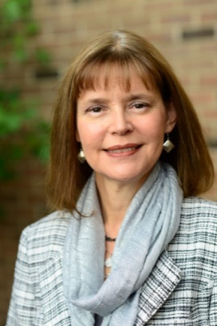
Connie Parenteau graduated from the University of Alberta with a Bachelor of Science in Electrical Engineering.
Governance Leadership is a significant area of knowledge. Connie had developed a good
Understanding of governance processes, policies and accountabilities within a regulatory organization. Familiar with discussion modes of fiducuary, strategic and generative. She is skilled at running a meeting efficiently and effectively.
In May 2016, Connie was appointed as Director on the Engineers Canada Board representing Alberta. At Engineers Canada, she also is serving on the Executive Committee which has been responsible for a recent CEO Search. The Executive Committee also acts as CEO Compensation Committee. Connie has also served on the Nominations Task Force, Bridging Engineering & Governance Committee and participated in an Engineering University Accreditation Visit.
She served the Association of Professional Engineers & Geoscientists (APEGA) as President from 2014-2016 and as APEGA’s Past President. She chaired many committees, including the APEGA Executive, Nominating and Governance. Currently, she is a member of the APEGA Nominating Committee
Connie led APEGA Council thru the development of APEGA’s new 2017-2022 Strategic Plan and has been fully engaged in the APEGA Legislative Review. She has been a significant driver in APEGA Council’s Governance Renewal which has streamlined the Council Committee structure. Most recently, she served on the APEGA Task Force recommending changes to the Governance System.
She worked for TELUS Communications in Edmonton for over 33 years, where she held a variety of technical, managerial and leadership positions and acted as a Responsible Member for the TELUS Corporation Permit to Practice for more than 15 years.
Throughout her career, she has supported gender diversity in the profession by acting as a role model and sharing her insights on career milestones.
She is a strong advocate of the importance of being involved in professional and community affairs. She has been active in non-profit organizations related to the performing arts, literacy and community services.

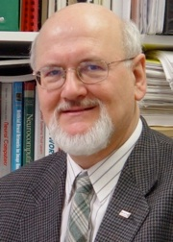
Witold Kinsner is Professor in the Department of Electrical and Computer Engineering, University of Manitoba (UofM), Winnipeg, Canada, and Director of the Cognitive Systems Group. He was a co-founder of the first Microelectronics Centre in Canada, and was its Director of Research from 1979 to 1987. He is a Co-founding Member of the International Institute of Cognitive Informatics and Cognitive Computing (ICIC), Calgary, and the Canadian Engineering Education Association (CEEA). Since 1971, he has been very active at all the IEEE levels, including IEEE International, Region 7 (IEEE Canada), Society, Council, Section, Chapter, and Student Branch. He has organized many conferences, and has been on numerous editorial boards of journals and magazines. He is a member of 10 IEEE Societies and many committees. In 2013, Dr Kinsner was elected IEEE Canada President Elect 2014-15 and IEEE R7 Director/Delegate Elect 2014-15. He was IEEE Canada President 2016-17 and IEEE R7 Director/Delegate 2016-17, and he is now its Past President 2018-2019. In 2017, he was elected IEEE Vice President of Educational Activities Board for 2018.

His current research focuses on entropy-based mono-scale, multi-scale, and poly-scale complexity metrics for cognitive systems. He has been involved in research on robust algorithms and software/hardware computing engines for real-time multimedia, using wavelets, fractals, chaos, emergent computation, genetic algorithms, rough sets, fuzzy logic, higher-order statistics, and neural networks. He has authored and co-authored over 780 publications in the above research areas, as well as supervised over 76 Master's and Doctorate graduate students, over 200 undergraduate final-year thesis/capstone project students, and mentored over 35 summer research students. He has received a number of awards. Since 2010, he has been the University Advisor for the Canadian Satellite Design Challenge (CSDC) University of Manitoba team consisting of over 100 students from 16 departments and 50 advisors from the academic, aerospace, industrial, business, and military sectors. In 2018, the fourth implementation of the University of Manitoba Space Applications and Technology Society (UMSATS)’s satellite, TSat4, has won the CSDC competition.

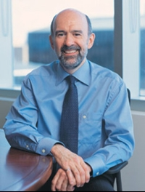
David Lynch received his Bachelor of Applied Science in Chemical Engineering from the University of New Brunswick (1977) followed by a PhD from the University of Alberta (1982) focused on the areas of catalysis and chemical reactor engineering. He is Professor Emeritus (Chemical Engineering) at the University of Alberta following 36 years as a faculty member including 21 years as Dean of Engineering (1994-2015). During his service as Dean, engineering undergraduate and graduate student enrolments doubled and quadrupled, respectively, to a total of over 6,000 students with over 18,000 engineering graduates, over 270 new engineering professors were hired, over 50 Chair positions (endowed, industrial and government funded) were established, and five large, new buildings were constructed for engineering education and research.

An active volunteer with the engineering profession, David served on the APEGA Board of Examiners for 21 years and he is currently a member of the APEGA Nominating Committee. He was a member of the Canadian Engineering Accreditation Board for 11 years, including serving as the Vice-Chair, Chair and Past-Chair during his final 5 years (2002-2007) on the CEAB. Associated with membership on the Engineers Canada Board, David participates in all APEGA Council meetings.

David serves on a number of boards of directors including Waste RE-solutions Edmonton (2492369 Canada Corporation), the German Canadian Centre for Innovation and Research, the Pure North S’Energy Foundation, and he is a member of the NSERC Committee on Research Partnerships as well as several other advisory committees and boards.

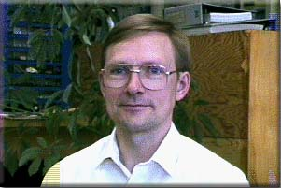
Dr Robert Fedosejevs has over 30 years experience in the development of laser systems and their applications in various areas including fusion energy research, the generation of XUV and soft x-ray radiation for lithography applications, micromachining, thin film coatings and studies in ultrafast phenomena.
Dr Fedosejevs' past research and development work includes the development and application of picosecond optical probe techniques to the study of high power laser-plasma interactions and high temperature plasma phenomena. He has been a visiting scientist at the National Research Council of Canada, the Max-Planck-Institute fuer Quantenoptik in Germany, CELIA (Centre Laser Intenses et Applications) at Bordeaux and at the Institute for Laser Engineering at Osaka University in Japan. He has worked on a number of laser systems including high power nanosecond carbon-dioxide, iodine and glass lasers, picosecond glass and krypton fluoride lasers, and femtosecond krypton fluoride and Ti:Sapphire laser systems. With these systems he has studied a number of high temperature plasma phenomena including absorption, plasma instabilities, x-ray generation, hydrodynamics of the laser produced plasmas and applications in micromachining, laser sensing and laser deposition of thin film coatings. Many of the studies have been related to the quest to develop laser fusion energy.

Dr Fedosejevs has published over 200 research papers.
Dr Fedosejevs' current research interests include:

Application of lasers in material identification sensor applications using techniques such as laser induced breakdown spectroscopy, Raman spectroscopy and laser induced fluorescence.
Devlopment of high power pulsed fibre and solid state lasers.
Laser Fusion Energy and Fast Ignition.
Wakefield acceleration of MeV electrons.
Laser plasma interactions on femtosecond and picosecond time scales, including: absorption of laser light, multiphoton ionization and hydrodynamics.
Femtosecond generation of x-rays and applications to time resolved x-ray microsocpy.
Femtosecond laser micromachining.
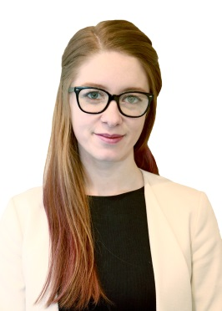
Development of a high energy proton telescope for applications in space and laser plasma research.
Rosalie has a Master of Arts in Economics and a Bachelor of Arts in Honours Mathematical Economics from the University of Waterloo. Prior to joining the C.D. Howe Institute as a Policy Analyst in 2016, she was a Research Analyst at the Ontario Ministry of Finance in the Office of Economic Policy. Beginning in 2018, she became the director of the Health Policy Research Program and leads the C.D. Howe Institute Health Policy Council.
Rosalie’s current research focuses on policy issues affecting healthcare in Canada with the goal of identifying policy gaps and misaligned incentive mechanisms to assess potential causes and propose solutions that drive efficiency and value. Rosalie also researches the implications of technology and innovation on all parts of the economy and has written on the topic from an international, human capital, fiscal and tax perspective.
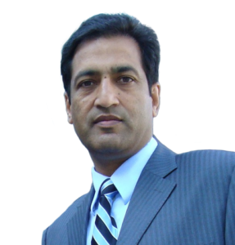
Ravinder Shergill is the Principal Architect, responsible for Smart Cities Reference Architecture. With his deep, 30 year experience in networking, he helps set the strategy for next-generation architectures that promote industry ecosystem adoption, builds cross-segment synergies between different ‘tenants’ of the network.

He has served in a variety of lead roles at TELUS, including Software Defined Networking (SDN) Strategist, Converged Core Architect, Converged Edge Architect, IPv6 Enablement Program lead, CO Rationalization – defining the next generation topology in an all-Fiber and all-IP ‘application centric’ infrastructure.

As the Chief Architect, he is presently the technical prime for the Smart Cities Architecture and Strategy for TELUS. Having lead a highly converged architecture from the core of the network to the edge over the past decade+, now he’s rationalizing Smart Cities paradigm leveraging Cloud, IOT, 5G, Virtualization and Softwarization trends, paving the way for a Smarter future.

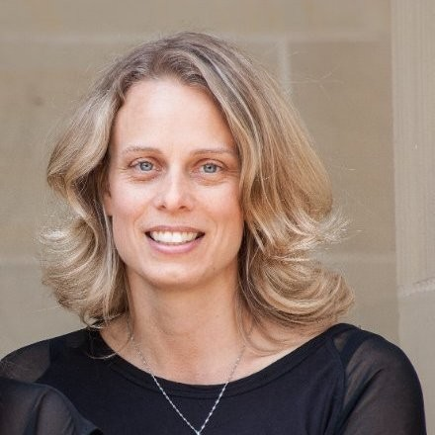
Carla Otto is the Director Regional Innovation with Alberta Innovates.

Alberta Innovates supports research and innovation to facilitate the commercialization of novel advances in technology and knowledge-based industries within Alberta’s innovation system. Through a suite of programs and services for entrepreneurs, small-medium size enterprises (SMEs) researchers and investors, AI has created an innovation support system that is a one-stop shop to develop knowledge-based industry clusters and encourage Alberta’s entrepreneurial culture.

In 2012, Carla Otto joined Alberta Innovates (AI) as the Director, IP and Investment Services and is currently the Director, Regional Innovation in the Entrepreneurial Investments branch. Previously she was the Senior Director, Scientific Operations at Afexa Life Sciences helping grow COLD-FX to a $50Million/year brand prior to its acquisition by Valeant Pharmaceuticals. At Afexa she developed strategies and executed projects in the areas of regulatory, IP, and global business development. Carla specializes in investment due diligence, financial analysis, intellectual property, and early stage business planning.

